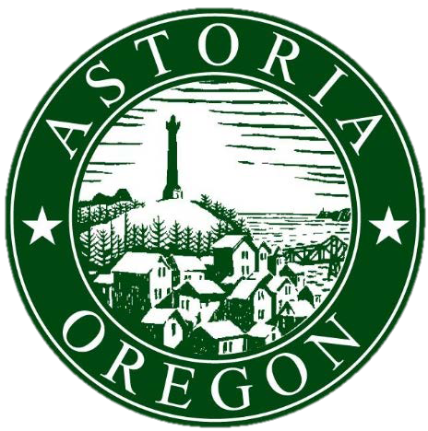City of Astoria

Arts & Culture Grant Application

For Fiscal Year Beginning July 1, 2025

The City of Astoria established the Arts and Cultural Program to provide funding to art and cultural events that will increase tourism in the City. Grant funding is provided through the Promote Astoria Fund which receives its funding from Transient Lodging taxes. The City will make available an amount not to exceed $100,000 for distribution in the fiscal year beginning on July 1, 2025. **The actual amount of funding will depend on resources available, and will be finalized during the annual budget process. Awards will not be final until the 2025-2026 Fiscal Year Budget is adopted by the City Council in June 2025.**

**Applications must be received by February 28, 2025 at 5:00 pm.**

ORGANIZATION

*Organization Name Contact Person and Title*

|  |  |
| --- | --- |
|  |  |

*Mailing Address*

|  |
| --- |
|  |

*Contact Phone Number Contact Email Address*

|  |  |
| --- | --- |
|  |  |

List of Board Members

|  |  |  |  |
| --- | --- | --- | --- |
|  |  |  |  |
|  |  |  |  |
|  |  |  |  |
|  |  |  |  |

Brief Background History of Organization *(max of 200 words):*

## EVENT OR PROJECT

This is a:  New Event  Reoccurring Event  One Time Project

*Provide an estimate of number of participants who will attend the event, activity, or project in each of the following categories. If this is a reoccurring event, please fill out the "prior year" numbers as well:*

Local Attendees expected Local Attendees (prior)

Surrounding Area Attendees expected Surrounding Area Attendees (prior)

How will your event, activity, or project promote or enhance tourism for Astoria? *(max of 200 words)*

What is the target age groups of your event, activity, or project?

How will you promote or market the event or project outside Astoria to attract out-of-area attendees?*(max of 200 words)*

How will the event, activity, or project impact local businesses, restaurants, and hotels? *(max of 200 words)*

Describe the community appeal and/or support of your event, activity, or project*: (max of 200 words)*

How will you measure the success of your event, activity, or project*? (max of 200 words)*

BUDGET

What is the total budget of the activity that you are seeking City funds for?

|  |
| --- |
|  |

What percentage of your organization’s budget originates from lodging tax funding?

|  |
| --- |
|  |

List how requested funds will be allocated:

|  |  |
| --- | --- |
|  |  |
|  |  |
|  |  |
|  |  |
|  |  |
|  |  |

What other sources of funding have you applied for or secured for these operations?

|  |  |
| --- | --- |
|  |  |
|  |  |
|  |  |
|  |  |

Have you received city funds in the past? Yes No

If you are requesting more funds than you have in the past, what is the reason for the increase? *(max of 100 words)*

CERTIFICATION & ATTACHMENTS

*I hereby state on behalf of (Organization) that:*

This is an application for funding from the City of Astoria. If funding is awarded, my organization intends to sign a Grant Agreement with the City of Astoria.

I am authorized to apply for these funds on behalf of the organization.

Funds must be used as described in this application and the Grant Agreement. Any unused funds must be returned to the City prior to June 30, 2026.

If funding is requested for an event or activity, the organization has, or will obtain general liability insurance in an amount commensurate with the exposure of the event.

*Signature Date*

**APPLICATION DEADLINE: FEBRUARY 28, 2025 AT 5:00 PM**

**REQUIRED DOCUMENTS:**

1. Signed Application
2. Proof of 501-c3 status
3. Prior Year Financial Statement
4. Projected Annual Budget
5. Brochure or Letter of Support (Optional)

**SUBMIT TO:**

City of Astoria

Attn: Ryan Quigley 1095 Duane Street Astoria, OR 97103

Or via email at: [rquigley@astoria.gov](mailto:rquigley@astoria.gov)

All applications must be submitted by February 28, 2025, for consideration. Organizations making applications are not required to be present for budget committee review. Notification of award will be made upon budget adoption by the City Council in late June.